

Join as a Friend
Help get the change people really want by becoming a Friend of the Conservatives. As well as helping us get rid of this incompetent Labour Government at the next election, you can help make change happen in your local community now – for example, by joining one of our Social Action projects. As a Friend, in return for a donation of your choice, you’ll receive a weekly e-newsletter and access to our new affinity programme, which offers discounts on a great range of products.

Join as a Member
Members of the Conservative Party enjoy all the benefits that Friends do, but play a more active role in the Party. For just £25 a year (or £5 a year if you are 22 or under), you get to vote for the Party Leader and help choose our candidates for Parliamentary, local government and European elections. You’ll also be invited to attend our Party Conferences. Becoming a Member is a great way to have your say and help make change happen.

Make a Donation
We want to end the ‘big donor culture’ in British politics, so political parties don’t depend on large donations from trade unions, business or individuals. And we want to avoid having to ask taxpayers for more money to pay for politics. That means we need more financial support from people like you. However much or little you give, it will be put to good use – exposing the incompetence of this Labour Government and campaigning for the change that people in this country really want.

Become a Councillor
Becoming a Councillor is a most rewarding experience. It gives you the opportunity to help your local community, gain political experience, and develop useful skills in public speaking and problem solving. New Councillors bring fresh ideas and fresh enthusiasm to local politics.
JOIN US AND MAKE
CHANGE HAPPEN
FRIEND, MEMBER,
DONOR

Ways to join us:
- Complete the form overleaf and send it to us:
<Local address line 1>
<Local address line 2>
<Local address line 3>
<Local address line 4>
- Call us on <Local telephone number>
- Visit <Local web site address> and click ‘Join Us’

TO JOIN US, PLEASE FILL IN THE FORM BELOW

- Join as a Friend (donation of your choice)
- Join as a Member (£25 per year, or £5 per year if you are 22 or under)
- Make a Donation
- Become a Councillor – please contact me with further details
- Renew my Membership of the Conservative Party

Your personal details

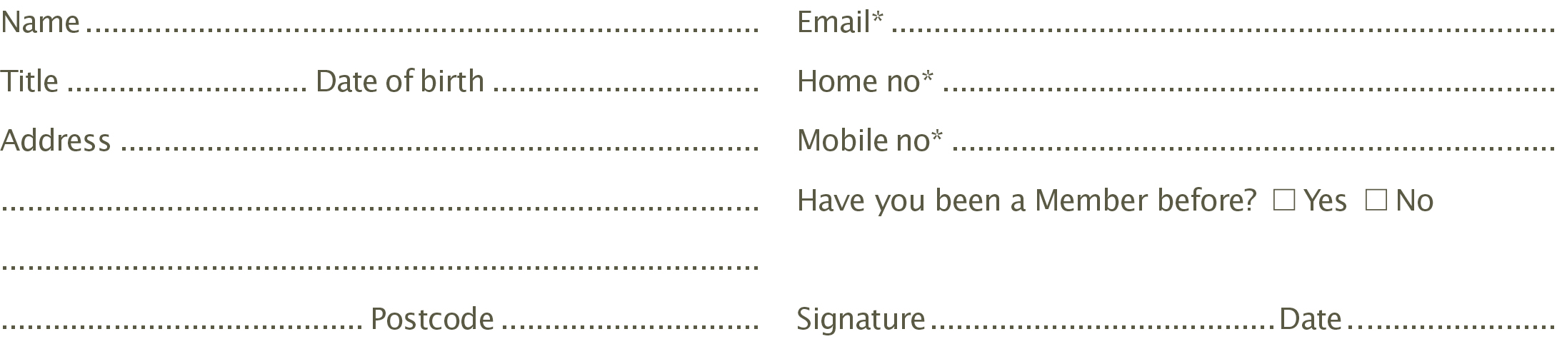
Your payment details: cheque/card
 £5 (22 or under)  £25 (recommended minimum)  £50  £75  £100  Other £ ………………
 I enclose a cheque made payable to <Name of Association>.
 I wish to pay by Card: Debit  MasterCard  Visa  Start date - Expiry date -
Card number --- Issue number (if applicable) 
CVS number  (3-digit number on the signature panel on the back of the card)

Your payment details: Standing Order
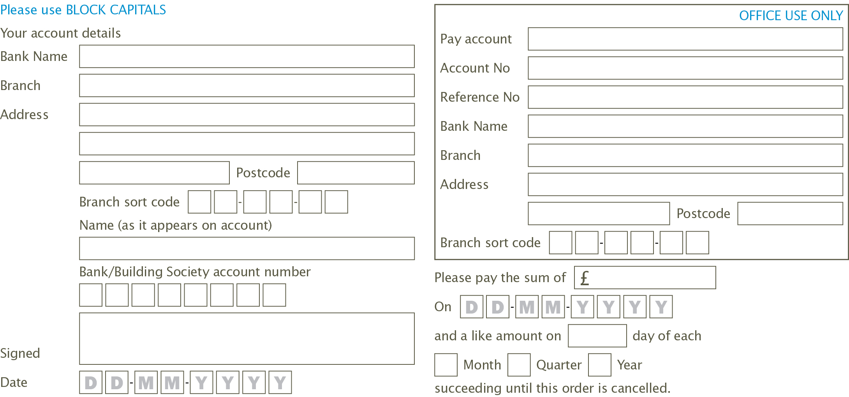

Help us, to help you
 I can display a poster at election time  I can deliver leaflets
 I can help with stuffing envelopes  I would like to attend social events
 I would like to buy draw tickets  I would like to attend Party Conference
You must be on the electoral register in the UK excluding the Channel Islands and the Isle of Man in order to make a donation of more than £200.
*By giving us your email address and/or mobile number, you are agreeing to receive communications and information from us by email or SMS. If you are registered for the Telephone Preference Service, by giving us your telephone number you are giving us permission to ignore this and occasionally call you.
** In order to qualify as a member with full voting rights, the minimum subscription is £<insert local amount>. This does not apply if you are 22 or under.

Promoted and printed by <Name> on behalf of <Name of Association>, both at <Local Address>.

 I would like to join a local campaign team  I would like a Postal Vote

