MEMBERSHIP JOINING FORM

My personal details Please complete as necessary
Name …………………………………………….

Address ……………………………………………

……………………………………………

……………………………………………

……………………………………………...

Home no: …………………………………………………

Mobile no:* ………………………………………………

Email:* …………………………………………………..

Date: ……………………………………………………..
:

My payment details: Cheque
Please find enclosed cheque for £ as payment of my new subscription to the Conservative Party.

Payable to: KEIGHLEY & ILKLEY CONSERVATIVE ASSOCIATION for:
 £5 (22 or under)  £25 (recommended minimum)  £50  £75  £100  Other £ ………………

Your payment details: Standing Order
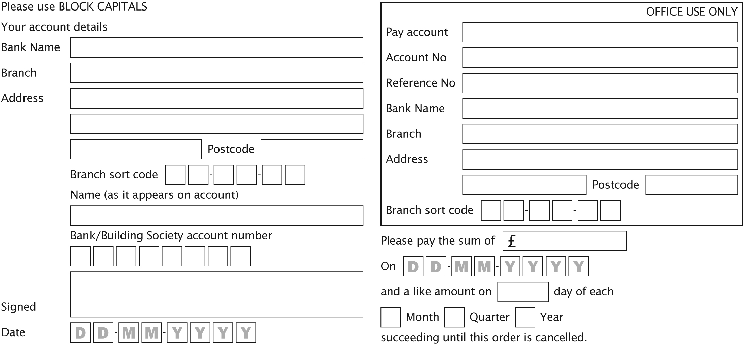

How you can help us
 I can display a poster at election time  I can deliver leaflets
 I can help with stuffing envelopes  I would like a postal vote
 I would like to attend social events  I would like to buy draw tickets
 I would like to attend Party Conference  I would like to stand for Council
You must be on the electoral register in the UK excluding the Channel Islands and the Isle of Man in order to make a donation of more than £500.
*By giving us your email address and/or mobile number, you are agreeing to receive communications and information from us by email or SMS. If you are registered for the Telephone Preference Service, by giving us your telephone number you are giving us permission to ignore this and occasionally call you.
** In order to qualify as a member with full voting rights, the minimum subscription is £25. This does not apply if you are 22 or under.

Printed by Michael P Gibbons for Keighley & Ilkley Conservative Association, Churchill House, Keighley, BD21 3AF.

Please return your form to:
Keighley & Ilkley Conservative Association, Churchill House, 21 North Street, Keighley, BD21 3AW.
Thank you.

